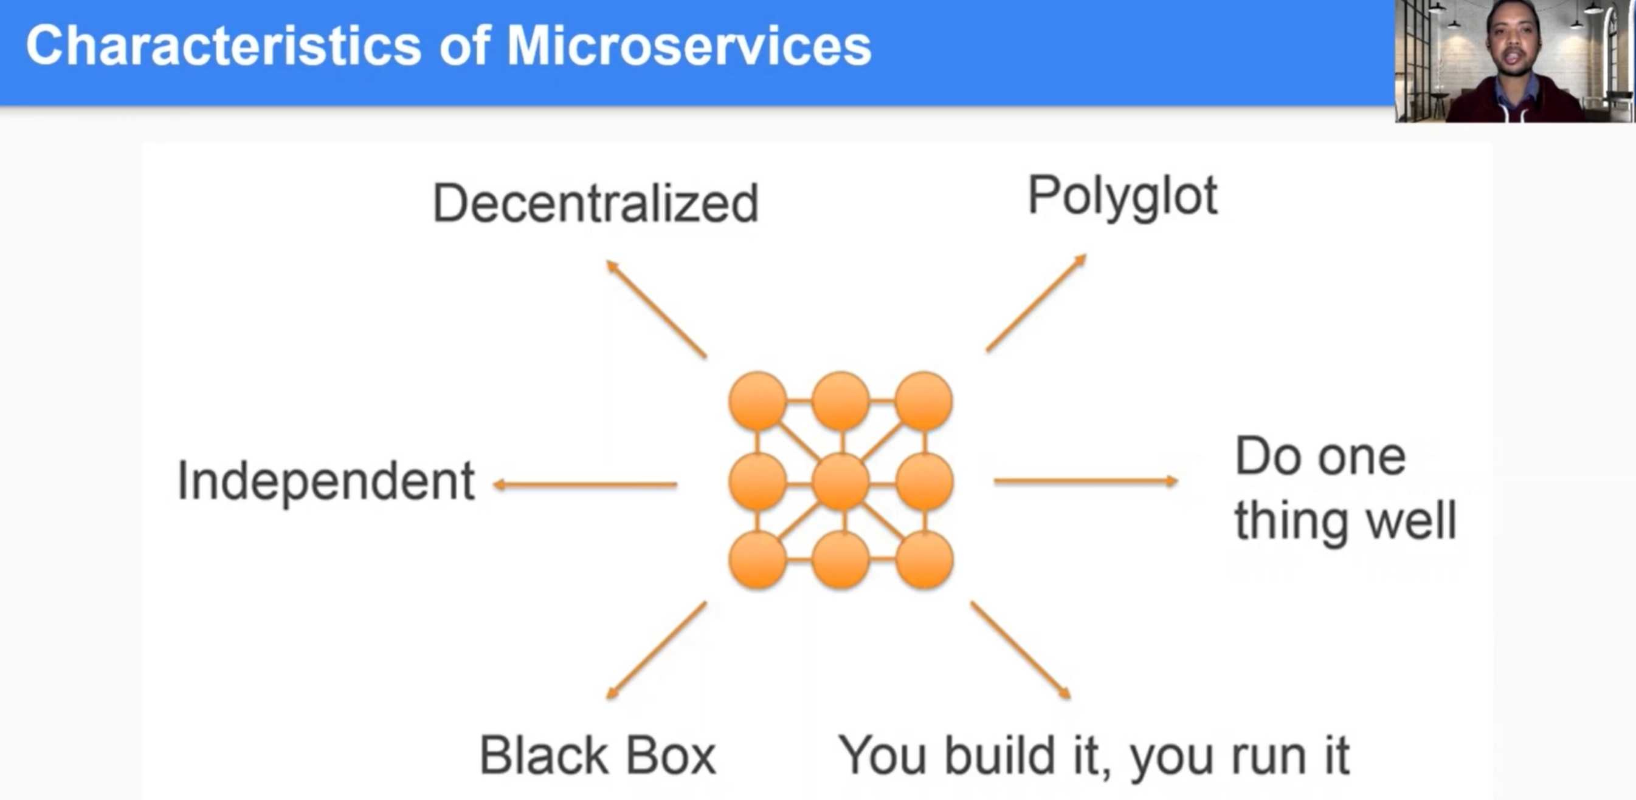

* Each service can run on different VM.
* If developer developing one service, then other service for him can be black box.
* Each service run independently.
* Focus for the developer is their own service so do one thing well
* Ownership of each microservice divide among team so you build it then you run it

